Practical : 22

## Aim: Write an exercise, to allow the user to ADD, UPDATE, MODIFY his profile once he has logged into the website using Bound and Unbound Controls.

Register.aspx

<%@ Page Language="vb" AutoEventWireup="false" CodeBehind="Register.aspx.vb" Inherits="Practical_22.Register" %>

<!DOCTYPE html PUBLIC "-//W3C//DTD XHTML 1.0 Transitional//EN" "http://www.w3.org/TR/xhtml1/DTD/xhtml1-transitional.dtd">

<html xmlns="http://www.w3.org/1999/xhtml">

<head runat="server">

<title></title>

</head>

<body>

<form id="form1" runat="server">

<div>

<strong>Ishan Jagani</strong><br />

<br/>

<asp:Label ID ="lblTitle" runat ="server" Text ="Register" style="font-weight: 700"/>

<br/><br/>

Username : <asp:TextBox ID ="txtUsername" runat ="server" PlaceHolder ="Username" />

<br/><br/>

Name :

<asp:TextBox ID ="txtName" runat ="server" PlaceHolder ="Name" />

<br/><br/>

Age :

<asp:TextBox ID ="txtAge" runat ="server" PlaceHolder ="Age" TextMode ="number" />

<br/><br/>

Password Password :

<asp:TextBox ID ="txtPassword" runat ="server" PlaceHolder ="Password" TextMode ="password"/>

<br/><br/>

<asp:Button ID ="btnRegister" runat ="server" Text ="Register" />

<br/><br/>

<asp:HyperLink ID ="hlLogin" runat ="server" Text ="Already have Account? " NavigateUrl ="~/Login.aspx"/>

<br />

<br />

<asp:Label ID ="lblAlert" runat ="server" ForeColor ="red"/>

</div>

</form>

</body>

</html>

Register.aspx.vb

Imports System.Data.SqlClient

Public Class Register

Inherits System.Web.UI.Page

Protected Sub Page_Load(ByVal sender As Object, ByVal e As System.EventArgs) Handles Me.Load

End Sub

Protected Sub btnRegister_Click(sender As Object, e As EventArgs) Handles btnRegister.Click

Try

Dim con As New SqlConnection

con.ConnectionString = "Data Source=(LocalDB)\MSSQLLocalDB;AttachDbFilename=C:\Users\ISHAN\Desktop\Databases\UserDetails.mdf;Integrated Security=True;Connect Timeout=30"

Dim cmd As New SqlCommand

cmd.Connection = con

cmd.CommandText = "insert into UserInfo values ('" & txtUsername.Text & "','" & txtName.Text & "','" & txtAge.Text & "','" & txtPassword.Text & "')"

con.Open()

cmd.ExecuteNonQuery()

con.Close()

Response.Redirect("~/Login.aspx")

Catch ex As Exception

lblAlert.Text = "This user is already registered with us!"

End Try

End Sub

End Class

Login.aspx

<%@ Page Language="vb" AutoEventWireup="false" CodeBehind="Login.aspx.vb" Inherits="Practical_22.Login" %>

<!DOCTYPE html PUBLIC "-//W3C//DTD XHTML 1.0 Transitional//EN" "http://www.w3.org/TR/xhtml1/DTD/xhtml1-transitional.dtd">

<html xmlns="http://www.w3.org/1999/xhtml">

<head runat="server">

<title></title>

</head>

<body>

<form id="form1" runat="server">

<div>

<strong>Ishan Jagani</strong><br/>

<br />

<strong>

<asp:Label ID ="lblTitle" runat ="server" Text ="Login" />

<br/></strong><br/>

Username :

<asp:TextBox ID ="txtUsername" runat ="server" PlaceHolder ="Username" />

<br/><br/>

Password :

<asp:TextBox ID ="txtPassword" runat ="server" PlaceHolder ="Password" TextMode ="password" />

<br/><br/>

<asp:Button ID ="btnLogin" runat ="server" Text ="Login" />

<br/><br/>

<asp:HyperLink ID ="hlRegister" runat ="server" Text ="Not Registered?" NavigateUrl ="Register.aspx"/>

<br />

<br />

<asp:Label ID ="lblAlert" runat ="server" ForeColor ="red"/>

</div>

</form>

</body>

</html>

Login.aspx.vb

Imports System.Data.SqlClient

Public Class Login

Inherits System.Web.UI.Page

Protected Sub btnLogin_Click(sender As Object, e As EventArgs) Handles btnLogin.Click

Try

Dim con As New SqlConnection

con.ConnectionString = "Data Source=(LocalDB)\MSSQLLocalDB;AttachDbFilename=C:\Users\ISHAN\Desktop\Databases\UserDetails.mdf;Integrated Security=True;Connect Timeout=30"

Dim cmd As New SqlCommand("select * from UserInfo where Username = '" & txtUsername.Text & "' and Password = '" & txtPassword.Text & "' ", con)

Dim ad As New SqlDataAdapter(cmd)

Dim ds As New DataSet

con.Open()

ad.Fill(ds)

con.Close()

If ds.Tables(0).Rows.Count > 0 Then

Session("username") = txtUsername.Text

Response.Redirect("~/Home.aspx")

Else

lblAlert.Text = "Wrong Username or Password!"

End If

Catch ex As Exception

Response.Write(ex)

End Try

End Sub

End Class

Home.aspx

<%@ Page Language="vb" AutoEventWireup="false" CodeBehind="Home.aspx.vb" Inherits="Practical_22.Home" %>

<!DOCTYPE html PUBLIC "-//W3C//DTD XHTML 1.0 Transitional//EN" "http://www.w3.org/TR/xhtml1/DTD/xhtml1-transitional.dtd">

<html xmlns="http://www.w3.org/1999/xhtml">

<head runat="server">

<title></title>

</head>

<body>

<form id="form1" runat="server">

<div align ="center">

Ishan Jagani<br/>

<asp:Label ID ="lblTitle" runat ="server" Text ="Your Details" />

<br/><br/>

<asp:Label ID ="lblName" runat ="server" Text ="Name: " />

<asp:Label ID ="lblNameVal" runat ="server" Text ="" />

<br/><br/>

<asp:Label ID ="lblUsername" runat ="server" Text ="Username: "/>

<asp:Label ID ="lblUsernameVal" runat ="server" Text ="" />

<br/><br/>

<asp:Label ID ="lblAge" runat ="server" Text ="Age: " />

<asp:Label ID ="lblAgeVal" runat ="server" Text ="" />

<br/><br/>

<asp:HyperLink ID ="hlEditDetails" runat ="server" Text ="Edit Details" NavigateUrl ="~/EditDetails.aspx" />

</div>

</form>

</body>

</html>

[Home.aspx.vb](http://Home.aspx.vb)

Imports System.Data.SqlClient

Public Class Home

Inherits System.Web.UI.Page

Protected Sub Page_Load(ByVal sender As Object, ByVal e As System.EventArgs) Handles Me.Load

Try

Dim con As New SqlConnection

con.ConnectionString = "Data Source=(LocalDB)\MSSQLLocalDB;AttachDbFilename=C:\Users\ISHAN\Desktop\Databases\UserDetails.mdf;Integrated Security=True;Connect Timeout=30"

Dim cmd As New SqlCommand("select Username, Name, Age from UserInfo where Username = " + Session("username"), con)

Dim ad As New SqlDataAdapter(cmd)

Dim ds As New DataSet

con.Open()

ad.Fill(ds)

con.Close()

lblNameVal.Text = ds.Tables(0).Rows(0).Item(0)

lblUsernameVal.Text = ds.Tables(0).Rows(0).Item(1)

lblAgeVal.Text = ds.Tables(0).Rows(0).Item(2)

Catch ex As Exception

Response.Redirect("~/Login.aspx")

End Try

End Sub

End Class

EditDetails.aspx

<%@ Page Language="vb" AutoEventWireup="false" CodeBehind="EditDetails.aspx.vb" Inherits="Practical_22.EditDetails" %>

<!DOCTYPE html PUBLIC "-//W3C//DTD XHTML 1.0 Transitional//EN" "http://www.w3.org/TR/xhtml1/DTD/xhtml1-transitional.dtd">

<html xmlns="http://www.w3.org/1999/xhtml">

<head runat="server">

<title></title>

</head>

<body>

<form id="form1" runat="server">

<div>

Ishan Jagani<br />

<br/>

<asp:Label ID ="title_label" runat ="server" Text ="Edit Details"/>

<br />

<br/>Keep the Textbox empty for the detail you don't want to edit.<br />

<br/>

<asp:TextBox ID ="txtName" runat ="server" PlaceHolder ="Name" />

<br/><br/>

<asp:TextBox ID ="txtAge" runat ="server" PlaceHolder ="Age" TextMode ="number" />

<br/><br/>

<asp:Button ID ="btnSave" runat ="server" Text ="Save" />

<br/><br/>

</div>

</form>

</body>

</html>

EditDetails.aspx.vb

Imports System.Data.SqlClient

Public Class EditDetails

Inherits System.Web.UI.Page

Protected Sub btnSave_Click(sender As Object, e As EventArgs) Handles btnSave.Click

Try

Dim con As New SqlConnection

con.ConnectionString = "Data Source=(LocalDB)\MSSQLLocalDB;AttachDbFilename=C:\Users\ISHAN\Desktop\Databases\UserDetails.mdf;Integrated Security=True;Connect Timeout=30"

Dim cmd As New SqlCommand

cmd.Connection = con

Dim usernm As String = ""

Dim age As String = ""

If (txtName.Text <> "") Then

usernm = "'" + txtName.Text + "'"

cmd.CommandText = "update UserInfo set Name = " + usernm + " where Username = " + Session("username")

End If

If (txtAge.Text <> "") Then

age = "'" + txtAge.Text + "'"

cmd.CommandText = "update UserInfo set Age = " + age + " where Username = " + Session("username")

End If

If (txtName.Text <> "" And txtAge.Text <> "") Then

cmd.CommandText = "update UserInfo set Name = " + usernm + ", Age = " + age + " where Username = " + Session("username")

End If

Dim ds As New DataSet

con.Open()

cmd.ExecuteNonQuery()

con.Close()

Response.Redirect("~/Login.aspx")

Catch ex As Exception

End Try

End Sub

End Class

Output :

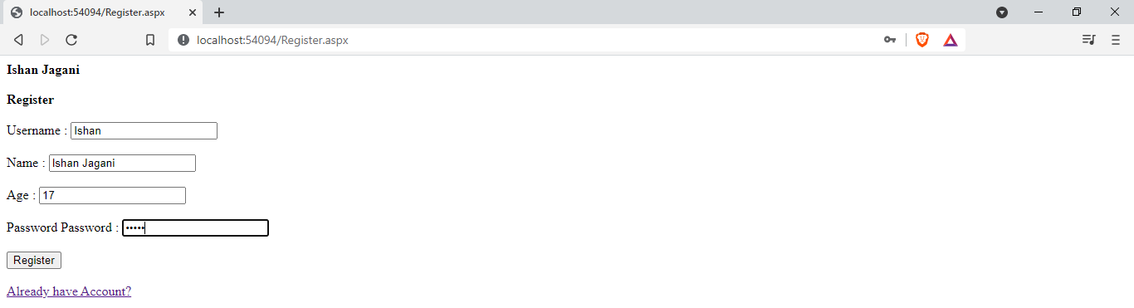

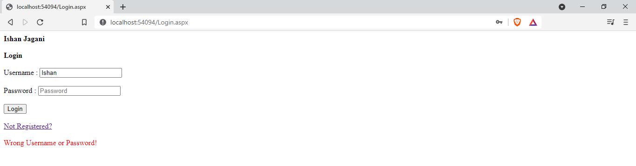

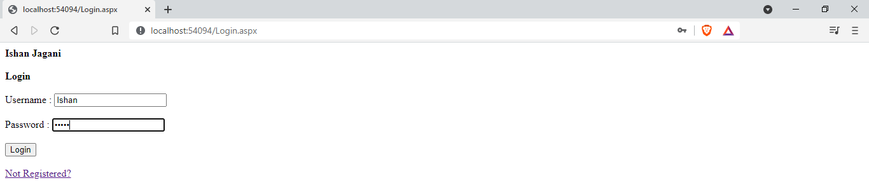

On Successful Login :

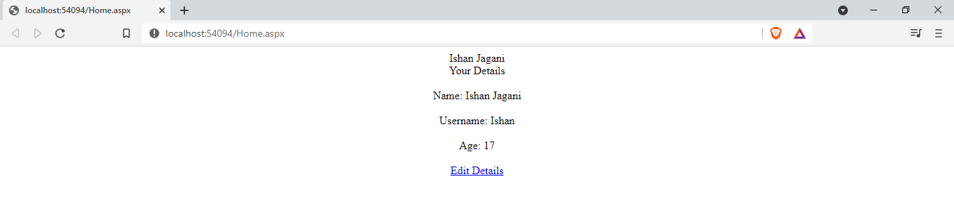

Edit Details:

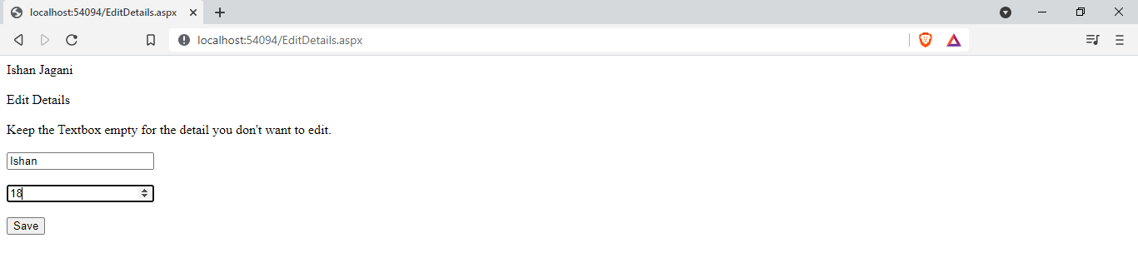

After Edit Details :

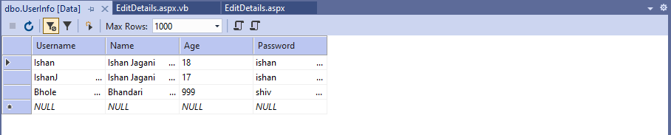

|  |  |  |  |
| --- | --- | --- | --- |
| Start Date | End/Sign Date | Faculty Sign | Remarks/Grade |
|  |  |  |  |